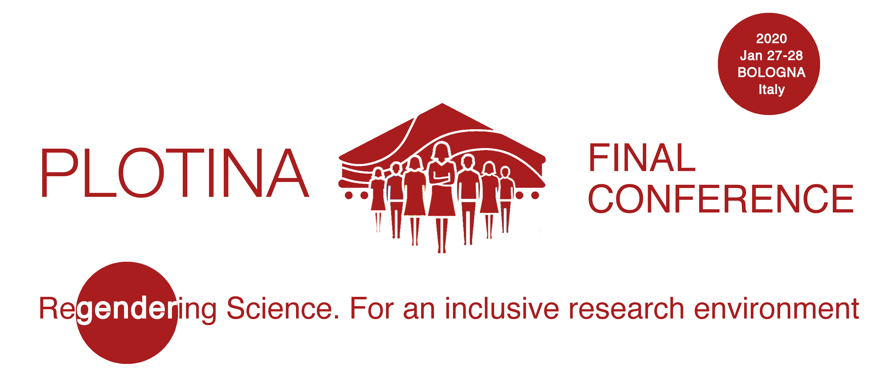
Dear XXX,
the Consortium of “PLOTINA. Promoting gender balance and inclusion in research, innovation and training” is pleased to invite you to take part to the project final conference “Regendering Science. For an inclusive research environment” (27th-28th January 2020, Bologna, Italy).
The international event will be hosted by the University of Bologna on the 27th -28th of January 2020.
The purpose of the conference is to present the project outcomes and to discuss with academics, key-actors from Research Performing Organizations and invited speakers about gender equality. The event will provide a unique venue to share experiences, case-studies and best practices in the following domains:
- Structural and cultural change: Gender Equality Plans and efforts
- The inclusion of the sex/gender variables in research
- The inclusion of the sex/gender variables and of gender equality issues in teaching curricula
- Assessing Gender Equality in Research Performing Organizations. Gender Report: indicators and tools
To this end, the PLOTINA Consortium has launched a call for contributions: https://www.plotina.eu/final-conference-call-for-papers/. To submit a proposal, please use the template for poster or abstract and the submission form available on the call webpage. Contributions will be accepted until the 8th of December 2019.
The conference will in English and it will be hosted by the University of Bologna (Department of Agricultural and Food Sciences, viale Fanin 44-46, Bologna, Italy).
The participation is free, but registration is required – please register online by visiting the website: https://www.plotina.eu/plotina-final-conference/

